Lab 09c - Implement Azure Kubernetes Service

This lab has the following tasks:

* Task 1: Register the Microsoft.Kubernetes and Microsoft.KubernetesConfiguration resource providers.
* Task 2: Deploy an Azure Kubernetes Service cluster
* Task 3: Deploy pods into the Azure Kubernetes Service cluster
* Task 4: Scale containerized workloads in the Azure Kubernetes service cluster

#### Task 1: Register the Microsoft.Kubernetes and Microsoft.KubernetesConfiguration resource providers.

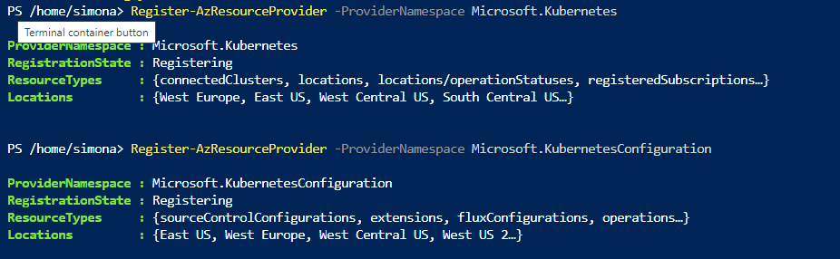

#### Task 2: Deploy an Azure Kubernetes Service cluster

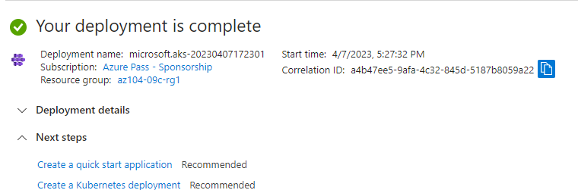

#### Task 3: Deploy pods into the Azure Kubernetes Service cluster

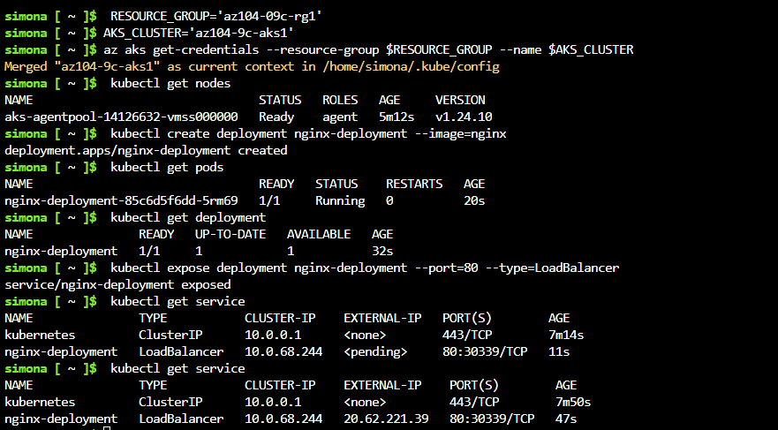

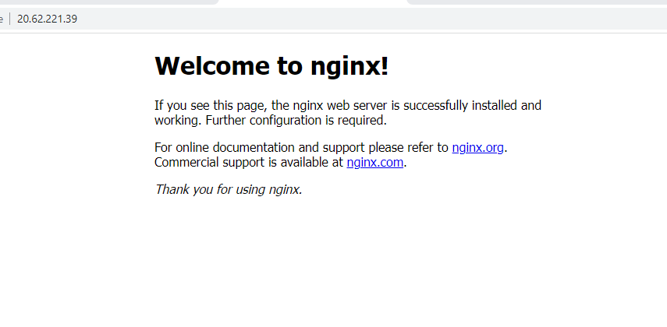

#### Task 4: Scale containerized workloads in the Azure Kubernetes service cluster

From the **Cloud Shell** pane, and run the following to scale the deployment by increasing of the number of pods to 2:

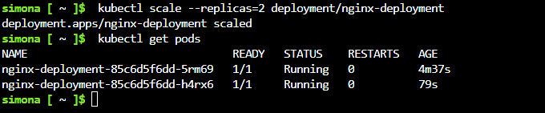

From the **Cloud Shell** pane, run the following to scale out the cluster by increasing the number of nodes to 2:

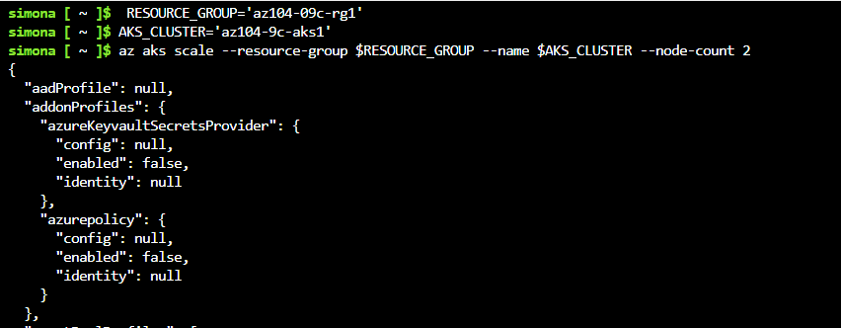

From the **Cloud Shell** pane, run the following to verify the outcome of scaling the cluster:

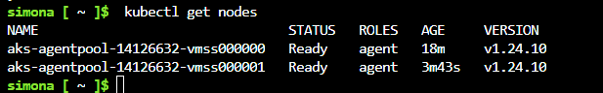

From the **Cloud Shell** pane, run the following to scale the deployment:

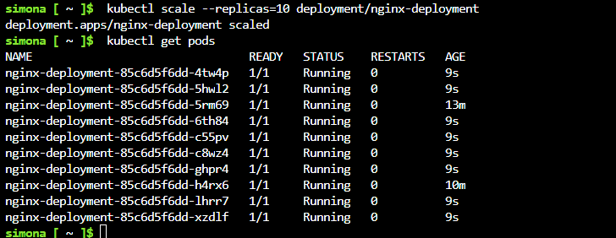

From the **Cloud Shell** pane, run the following to review the pods distribution across cluster nodes:

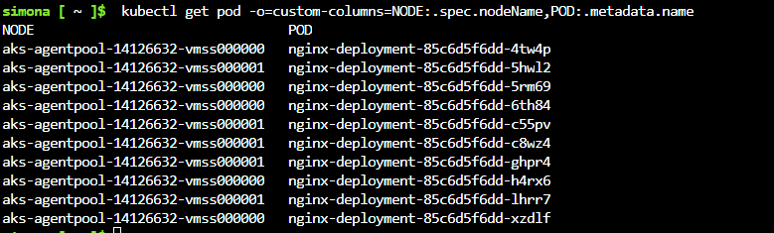

From the **Cloud Shell** pane, run the following to delete the deployment:

